Harnessing Data and Generative AI to Enhance Fitness Member Retention

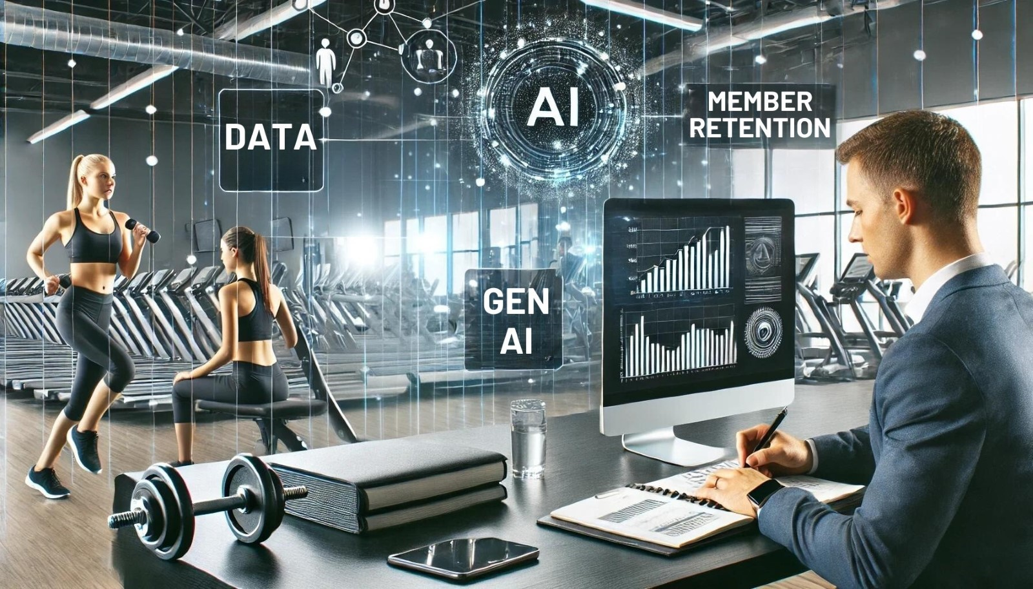

In the realm of fitness centers, data stands as the ultimate savior. It holds the power to transform vague assumptions into clear strategies, addressing one of the most pressing issues in the fitness industry: member retention. When utilized effectively, data doesn’t just offer insights; it provides actionable solutions that can significantly reduce cancellations and enhance the member experience. Generative AI amplifies this power by automating and enhancing data analysis, providing deeper insights and more personalized engagement strategies.

Understanding the Importance of Data

Data-driven decision-making has become a pivotal trend in many industries, and fitness centers are no exception. By collecting and analyzing data, gyms can gain insights into member behavior, preferences, and pain points. This information is invaluable for crafting targeted strategies to keep members engaged and reduce churn.

Key Data Points to Track

1. **Member Attendance Patterns**: Tracking how often and when members visit the gym helps identify trends and potential drop-off points. Understanding these patterns allows for timely interventions, such as personalized reminders or incentives to encourage attendance.

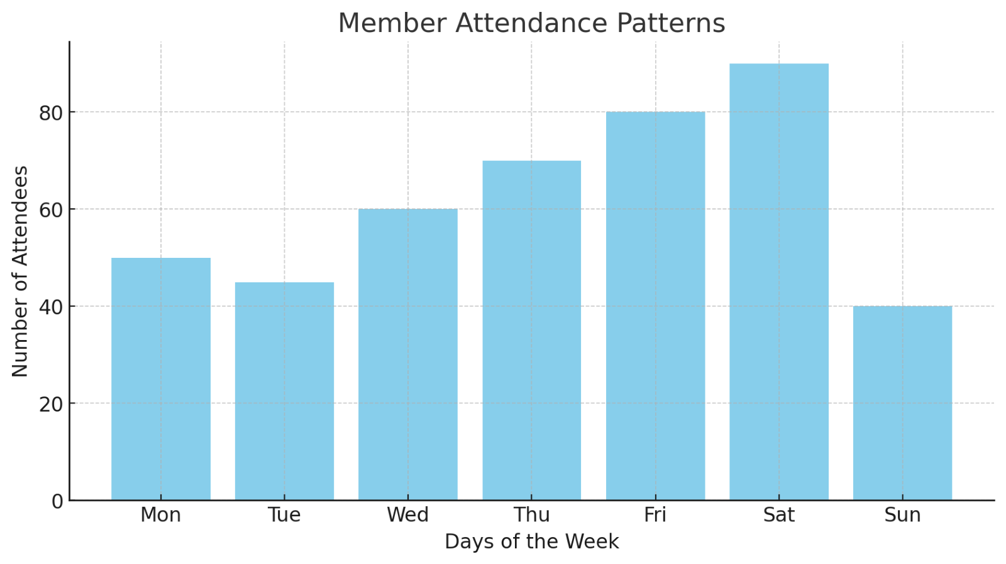

1. **Class and Equipment Usage**: Data on which classes are most popular and what equipment is frequently used can guide decisions on scheduling and investments. For instance, increasing the number of popular classes can boost member satisfaction and retention.

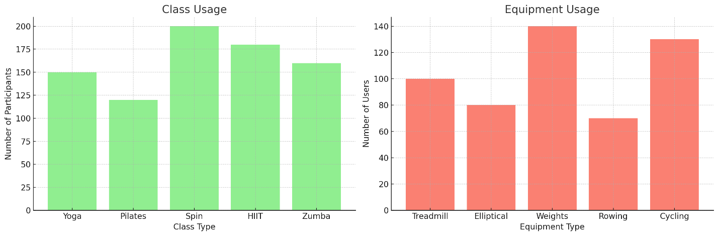

1. **Member Feedback and Satisfaction Scores**: Regularly gathering feedback through surveys or suggestion boxes provides direct insights into what members enjoy and what they feel needs improvement. Addressing these issues promptly can significantly enhance the member experience.

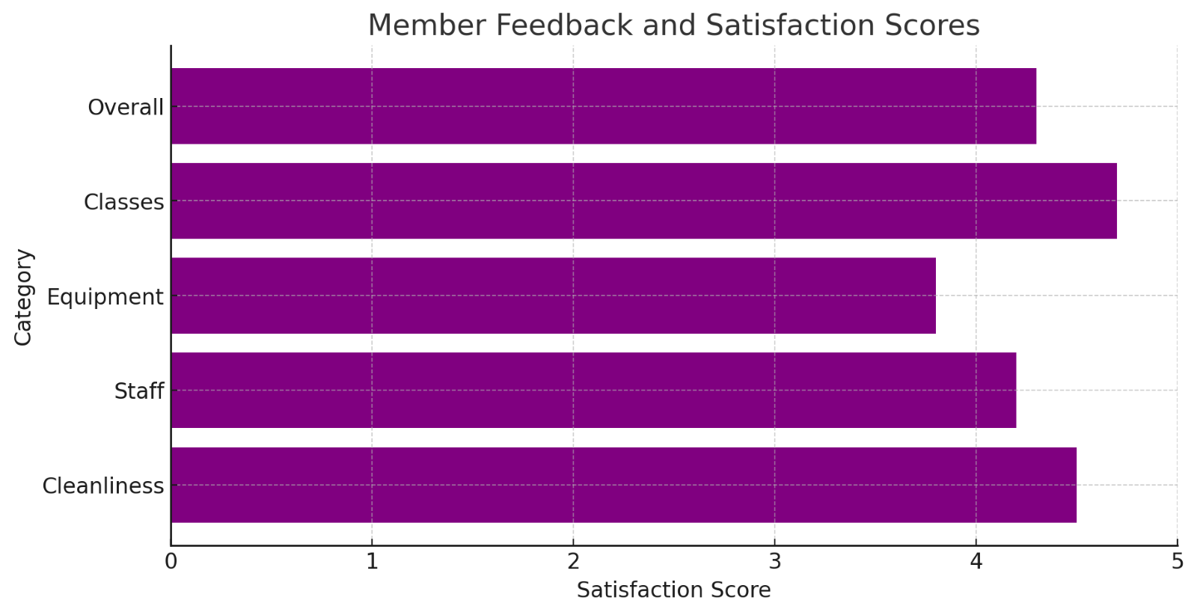

1. **Cancellation Reasons**: Analyzing why members cancel their memberships can highlight systemic issues within the gym. Whether it’s dissatisfaction with services, financial constraints, or relocation, understanding these reasons allows for the development of targeted retention strategies.

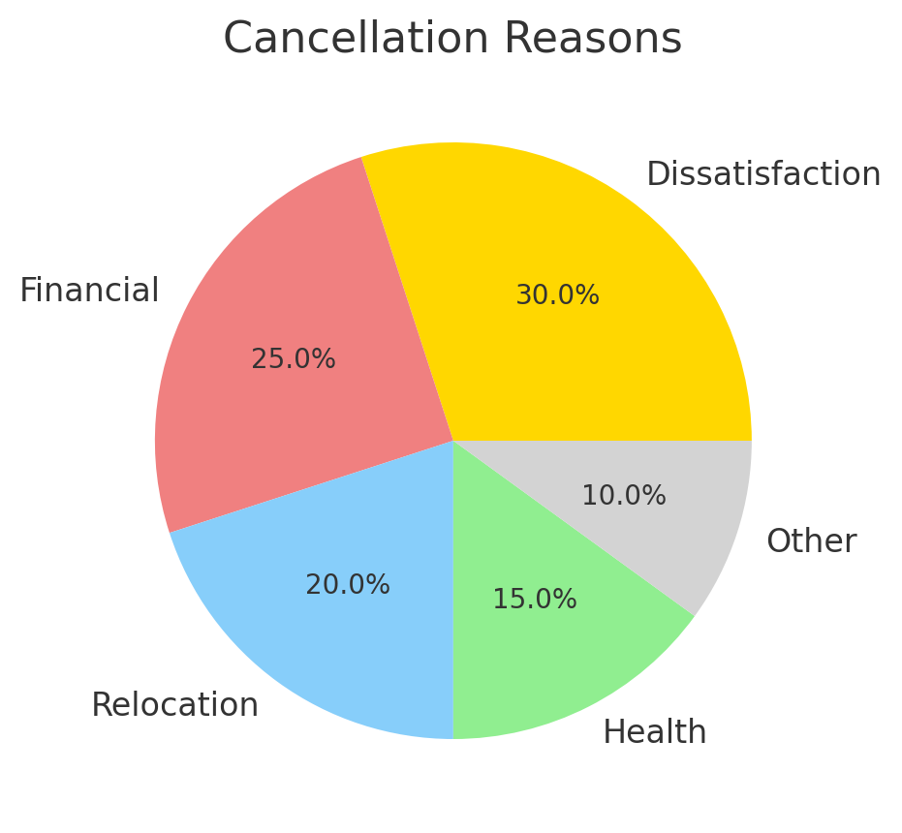

Integrating Generative AI for Enhanced Insights

Generative AI plays a transformative role in how data is utilized for retention strategies. Here’s how:

1. **Predictive Analytics**: Generative AI can analyze vast amounts of data to predict which members are at risk of canceling their memberships. By identifying these patterns early, gyms can proactively engage with these members through personalized offers and support, effectively reducing churn rates.
2. **Personalized Communication**: AI can automate the creation of personalized messages for members based on their behavior and preferences. For instance, if a member frequently attends yoga classes but hasn’t visited in a while, AI can generate a personalized email offering a discount on a new yoga program.
3. **Enhanced Member Engagement**: Generative AI can help create more engaging content for members, such as personalized workout plans, diet suggestions, and motivational messages. This personalized approach makes members feel valued and understood, increasing their likelihood of staying with the gym.
4. **Feedback Analysis**: AI can quickly analyze feedback from various sources, identifying common themes and sentiments. This rapid analysis allows gyms to address issues more efficiently and implement improvements that enhance member satisfaction.

Implementing a Data-Driven Culture

To fully benefit from data and AI, it’s essential to foster a data-driven culture within the organization. This includes training staff on the importance of data, how to collect it accurately, and how to use analytics tools effectively. Investing in the right technology and software solutions that integrate data collection and AI-driven analysis into everyday operations is also crucial.

Compliance and Ethical Considerations

While leveraging data and AI, it’s important to adhere to compliance and ethical standards. Members’ privacy should be respected, and data should be used responsibly and transparently. Ensuring compliance with online cancellation laws and data protection regulations builds trust and fosters long-term relationships with members.

Conclusion

Using data and generative AI to improve retention is not just about collecting information; it’s about turning that information into actionable insights. By understanding member behavior, preferences, and feedback, gyms can create personalized, engaging experiences that keep members coming back. Implementing predictive analytics and fostering a data-driven culture ensures that these strategies are both effective and sustainable. Ultimately, the strategic use of data and AI transforms the approach to member retention, driving both satisfaction and business growth.Shape   
   
 Discover how DXFactor’s Cancellation Save Solution can help your gym leverage data and generative AI to reduce cancellations and boost retention. Visit our [website](https://dxfactor.com/cancellation-save-solution/) to learn more and [schedule a demo](https://calendly.com/meetwithron-dx/30min) today!Shape

**Proposed URL**

https://dxfactor.com/harnessing-data-and-ai-to-enhance-fitness-member-retention

**UTM URL**

https://dxfactor.com/harnessing-data-and-ai-to-enhance-fitness-member-retention?utm_source=linkedin&utm_medium=social&utm_campaign=can_save&utm_content=data_ai_fitness_retention

**Meta Title**

Harnessing Data & AI for Fitness Member Retention

**Meta Description**

Learn how data and generative AI can reduce cancellations and boost member retention in fitness centers. Discover actionable insights and strategies today.

**Blog Tags**

* Fitness
* Generative AI
* Data Analytics
* Member Retention

**LinkedIn Post**

Harnessing Data and Generative AI to Enhance Fitness Member Retention

Leveraging data and generative AI provides actionable insights and personalized engagement strategies to keep members coming back. Our latest blog delves into how data along with AI and generative AI can transform member retention for fitness clubs.

Read more: https://dxfactor.com/harnessing-data-and-ai-to-enhance-fitness-member-retention?utm_source=linkedin&utm_medium=social&utm_campaign=can_save&utm_content=data_ai_fitness_retention

Learn how predictive analytics and AI-driven communication can transform your gym's retention efforts. By incorporating these strategies, your fitness center can effectively use data and AI to not only retain your members but also enhance their overall experience, ensuring long-term success and growth. Discover the power of data and AI in boosting your gym’s retention rates today!

@Dharmesh Trivedi | @Tejas Shah | @Ron Benamor | @Sundeep Sanghavi | @Al Noshirvani | @Harshil Shah

#memberengagement #fitnessindustry #fitnessbusiness #generativeai #customerretention #dataanalytics #artificialintelligence